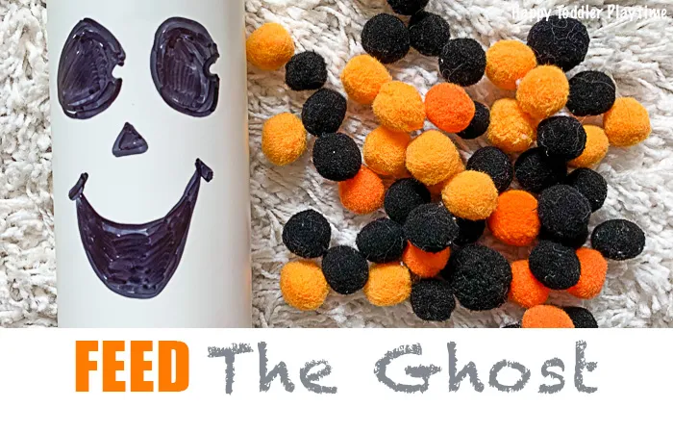
Activity packet

Feed the Ghost is a fun Halloween fine motor activity for toddlers using recycled materials and pom poms.

Materials required-
Any plastic container
Some colorful balls or paper cut outs of different colors
Sharpie

- Rinse and clean out your empty Lysol wipes container thoroughly. Remove the label. Take a back sharpie and draw the face of a ghost on the outside of the containers.
- Sort out the black and orange pom poms. You can also add purple and green pom poms for a collection of Halloween colors.
- Next, invite your kid to feed the ghost – who is very hungry.
- Use language targets such as “ghost is very hungry can we give him some yummy food”, lets give him more food (can also utilize sign of more), “look he is so full, I think he is all done” (again emphasize on the sign “all done”). Emphasize on using more sounds such as “yummy”, “nom nom” etc.
- Utilize fine motor strategies- Give only one pom pom to your kid by giving it from your hand so that he will emphasize on using the pincer grasp (between thumb and index finger) instead of using his entire hand to pick up pom-poms.
- Make the activity more engaging by taking turns with your child to feed the ghost.
- Parents or caregivers can demonstrate how to feed the ghost by dropping a pom pom through the top of the container.
- Work on sorting by adding in some imaginative play such as “ghost is a very picky eater and that it only like black pom poms and then have them sort through the pom poms to only feed them the black ones”.
Skills targeted-
- Language skills- powerful action words such as “eat”, “put in”, “more”, “all done”, sounds such as “nom nom”, “yummmm”.
- Fine motor skills- Works on pincer grasp while feeding the ghost.
- Cognitive and play skills- Pretend play skills, imaginative play, taking turns while playing.

